**PAPER TITLE, (Font Type-Times New Roman, Bold, Font Size 14)**

**First Author *1, Second Author*2, Third Author*3 (Font-** **Times New Roman, Bold, Font Size -11)**

1Affiliation, Department, Institute, City, State, Country (Font- Times New Roman, Font Size -10)

**ABSTRACT (Font-Times New Roman, Bold, Font Size -12)**

An abstract is a summary of entire paper should be written in Times New Roman with font size- 10. The abstract should not be more than 200 words and written in single paragraph. The abstract includes the overall purpose of the study you investigated, the basic design of the study, results of your analysis and brief summary of your interpretations and conclusion

**Keywords:** Analysis, investigation, research (5-6 Keywords, Times New Roman, Font Size – 10).

1. **INTRODUCTION (Font-** **Times New Roman, Bold, Font Size -12)**

The introduction should be typed in Times New Roman with font size 10. In this section highlight the importance of topic, making general statements about the topic and Presenting an overview on current research on the subject. The simplest way is to replace(copy-paste) the content with your own material. Your introduction should clearly identify the subject area of interest.

1. **METHODOLOGY (Font-** **Times New Roman, Bold, Font Size -12)**

Method and analysis which is performed in your research work should be written in this section. A simple strategy to follow is to use keywords from your title in first few sentences. (Font- Times New Roman, Bold, Font Size -10)

**Subheading**

Subheading should be (Font- Times New Roman, Bold, Font Size -10)

1. **MODELLING And ANALYSIS (Font-** **Times New Roman, Bold, Font Size -12)**

Related model of the study or instrumentation or materials used are well detailed in this section. (Font- Times New Roman, Bold, Font Size -10)

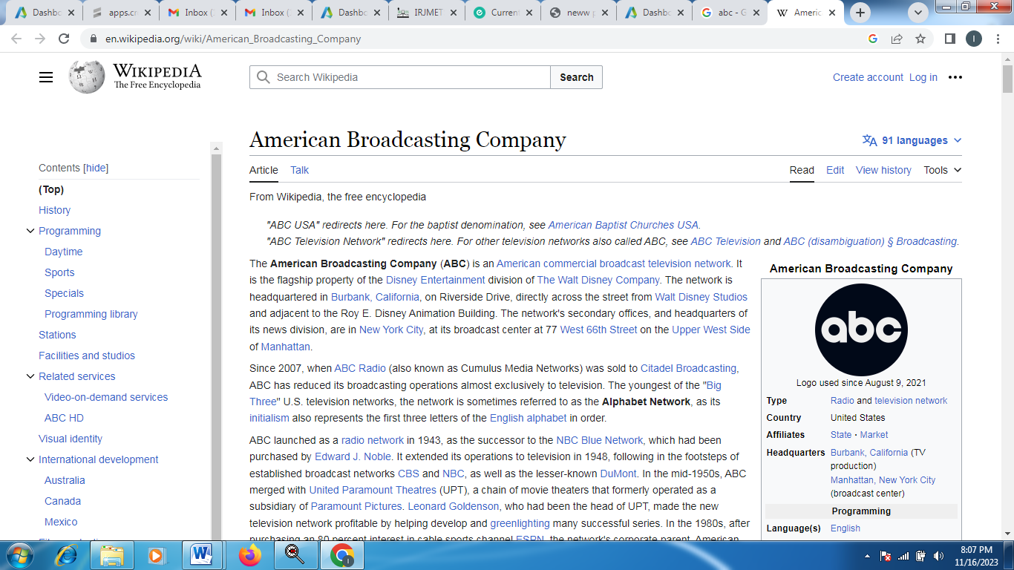

**Fig.1.** Sample figure

1. **RESULTS and DISCUSSION (Font-** **Times New Roman, Bold, Font Size -12)**

The results and discussion may be combined into a common section or obtainable separately. They may also be broken into subsets with short, revealing captions. It also include the graphical representation and tables. (Font- Times New Roman, Bold, Font Size -10)

**Table 1.** Details of the Sample

|  |  |  |  |
| --- | --- | --- | --- |
| SN. | Fig. title | Sample Size(mm) | Sample Diameter (mm) |
| 1 | ABC | 1mm | 1 mm |
| 2 | ABC | 1mm | 1 mm |
| 3 | ABC | 1mm | 1 mm |

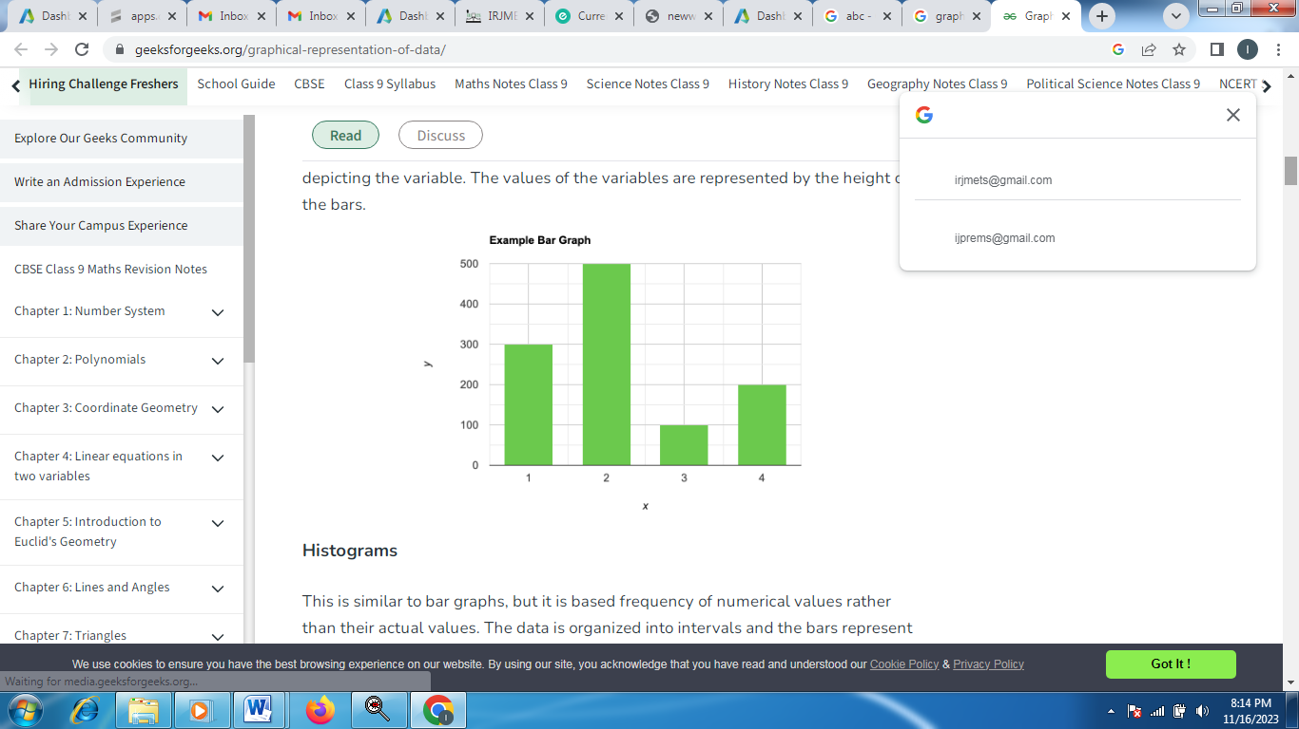

**Fig.2:** Graphical Representation

1. **CONCLUSION (Font-** **Times New Roman, Bold, Font Size -12)**

All the main points or overall conclusion of the research work are written in this section. Ensure that abstract and conclusion should not same. No figure or table include in this section.(Font- Times New Roman, Bold, Font Size -10)

**AKNOWLEDGEMENT (OPTIONAL)**

Thanks to guide parents

1. **REFERENCES (Font-** **Times New Roman, Bold, Font Size -12)**
2. Names of the author, Title of the paper, Volume 01, Issue 1, year 2023, pp 1-5 (Font- Times New Roman, Bold, Font Size -10)